.TECHNICAL PROJECT REPORT

# Title of Invention / Project:

RFID LOCK WITH ARDUINO

# Team Members / Inventors:

|  |  |  |  |  |  |
| --- | --- | --- | --- | --- | --- |
| **S.No.** | **Name** | **Department** | **Designation** | **Mobile** | **E-Mail** |
| 1. | Shaikh gulam jilani | cse | member | 8104355321 | gulamjilani61973@gmail.com |
| 2. | AAKASH KUMAR | CSE | LEADER | 7696146484 | aakashkumar160899@gmail.com |
| 3. | Isha limbu | cse | member | 8264610939 | ishalimbu001@gmail.com |
| 4. | Aman negi | cse | member | 9557926450 | amann931@gmail.com |
| 5. | Khushal Thakur | ECE | Mentor | 9646030764 | khushal.thakur@cumail.in |
| 6. | Anshul Sharma | ECE | Mentor | 9478697475 | anshulsharma.ece@cumail.in |
| 7. | Kiran Jot Singh | ECE | Mentor | 9463909689 | kiranjotsingh.ece@cumal.in |
| 8. | Divneet Singh Kapoor | ECE | Mentor | 9878422653 | divneet.ece@cumail.in |

Section – 1 (IPR Related)

# Brief Abstract (500 words):

* It is good looking suited for homes with good decor hassle free access to those whom you entrusted your lock password using card.
* It is cheap version of electronic lock we have used big arduino
* and rfid reader to read the genuine card and give access to people with right card it has buzzer which beeps accordingly.
* We have used bulky arduino Uno but we can use small microprocessors we can use Bluetooth for opening lock we can connect it with net and programme it send us information if someone was trying to access lock illegally we can use finger scanner to unlock the lock

# Existing state-of-the-art and Drawbacks in existing state-of-the-art

|  |  |  |
| --- | --- | --- |
| **S. No.** | **Existing state of art** | **Drawbacks in existing state of art** |
| 1 | BULKY | Not easy to install or it is not very much portable |
| 2 | RUNS ON MAIN POWER SUPPLY | IF power goes off u cannot open it manually |

# Novel/Additional modifications that you can propose to improve upon drawbacks

*(List down the features)*

* Rechargeable battery can be integrated
* We can use arduino nano

# Advantages

(*List down the advantages, if each feature is incorporated)*

* We can access lock if electricity goes off.
* It will reduce the size of lock .

# Block Diagram

(*Functional diagram depicting the flow of information in your system. Do not define exact components, only use generic terms. Must include modification*

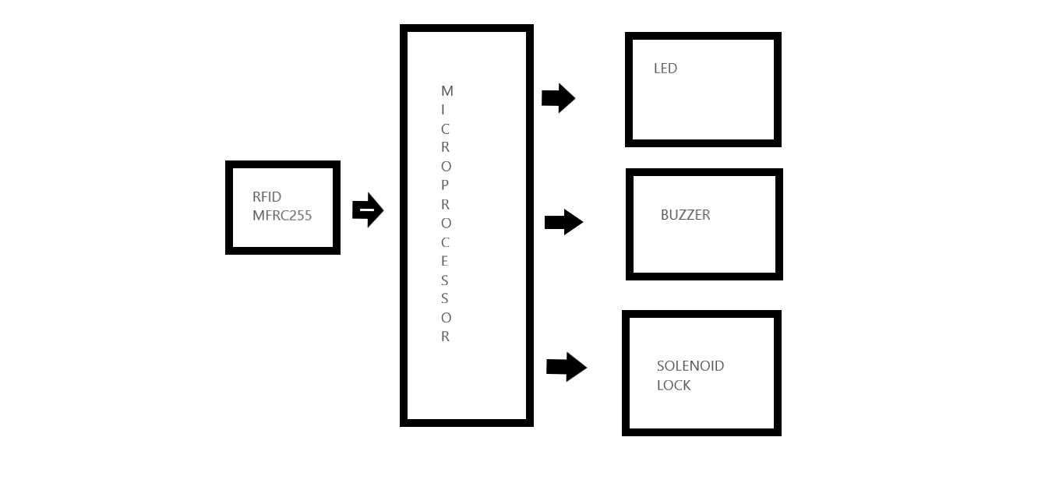

Section – 2 (Real Project)

# MateriaL

|  |  |
| --- | --- |
| 1 x RFID MFRC522 (SPI communication) | RS 225 |
| 1X SOLENOID LOCK | RS 525 |
| 2 X LED | FREE FROM LAB |
| 1 X BREAD BOARD | RS 70 |
| 1 X BUZZER | RS 25 |
| 1 X ARDUINO | RS 525 |
| 2 X 220 OHM RESISTOR | FREE FROM LAB |
| WIRES AND CABLES FOR CONNECTION | RS 125 |
| 1 X 12 V POWER CABLE | RS 300 |
| 1 X RELAY | RS 80 |
| TOTAL MONEY SPENT | RS 1875 |

# 

# Circuit Diagram

(*Fully functional circuit diagram with exact connections. Can use Fritzing/Proteus*)

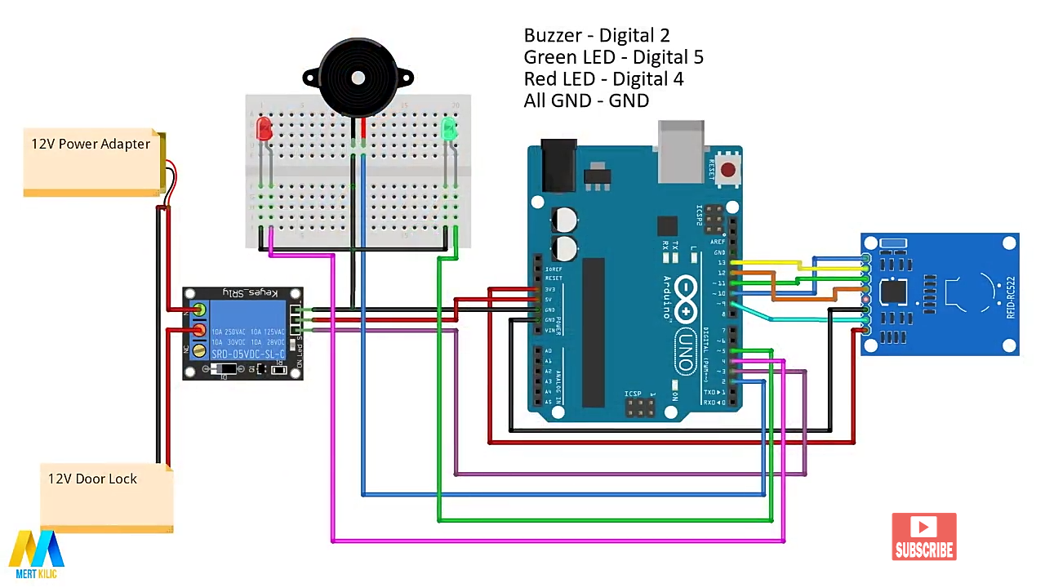

# Steps of Circuit Completion

(*Bifurcate the circuit completion in steps, specify with photographs, leading to final project*)

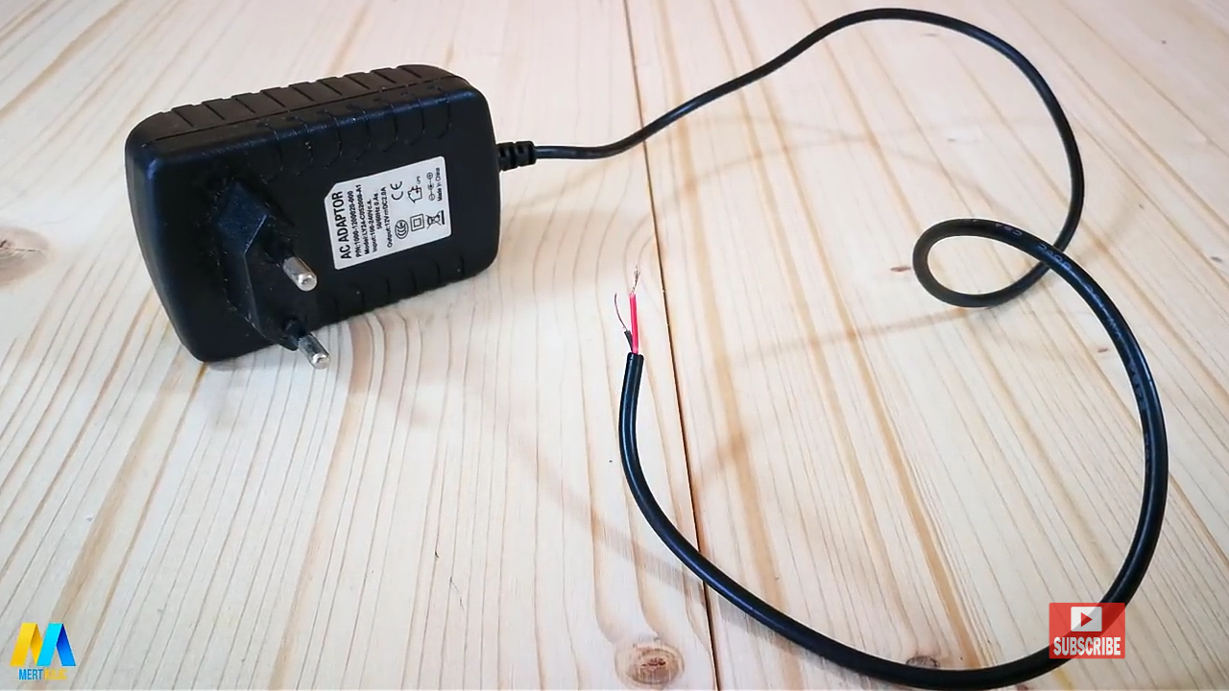

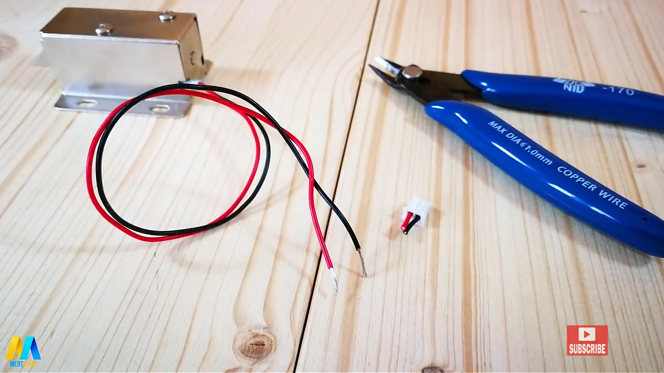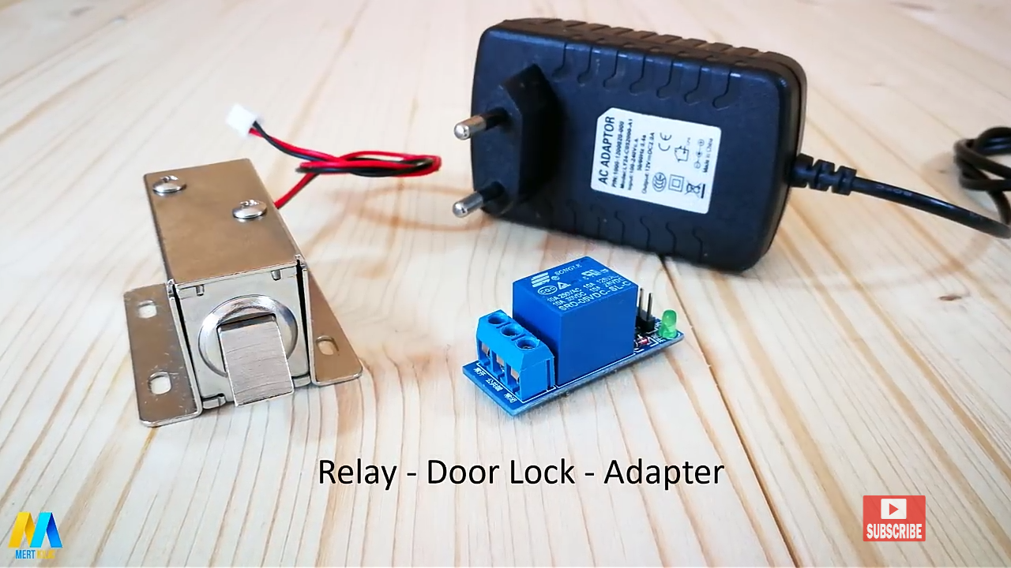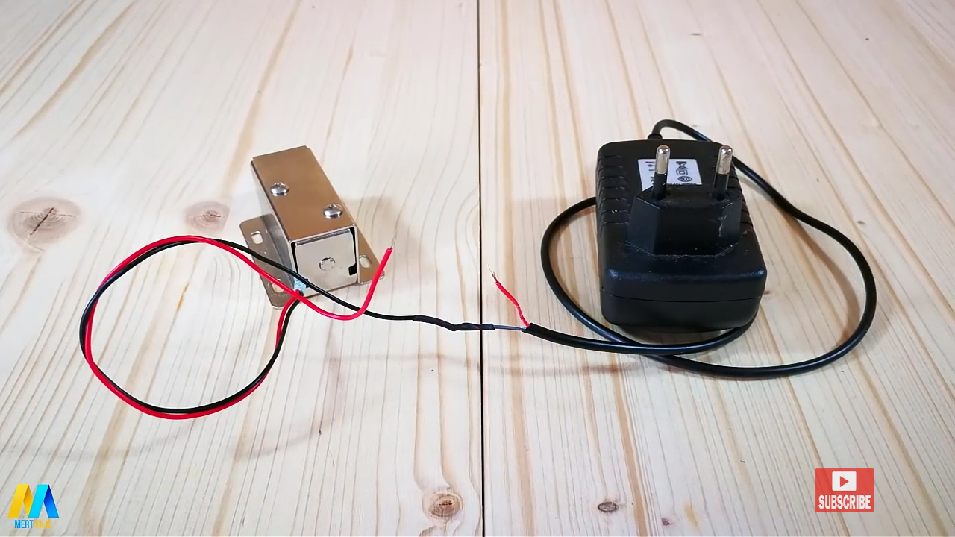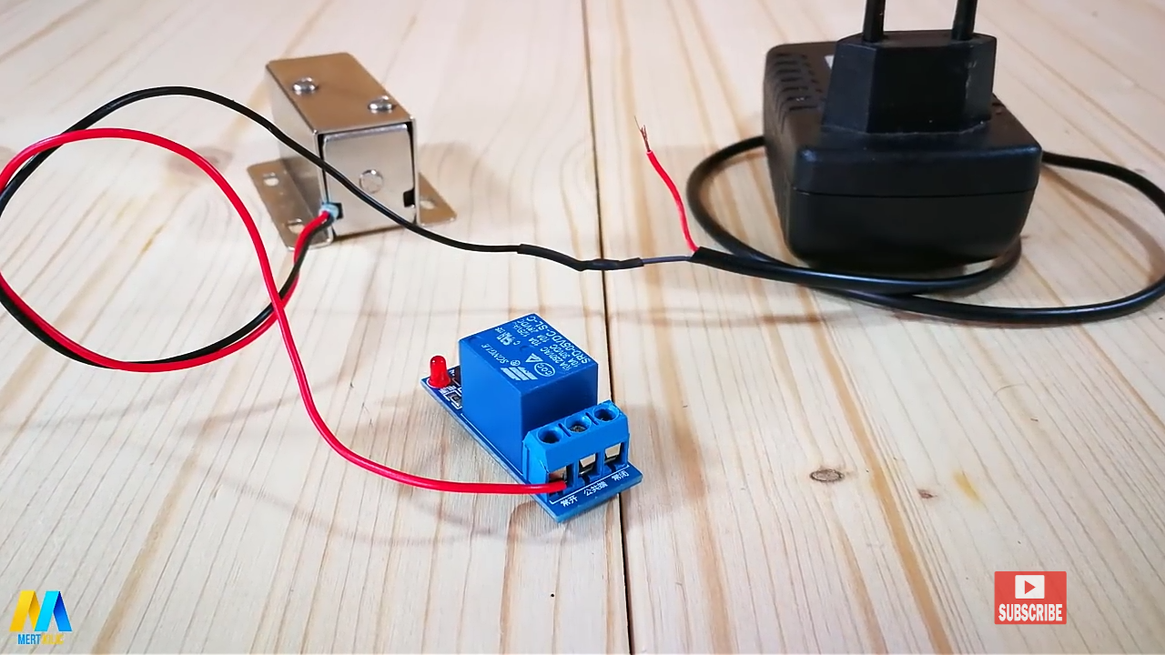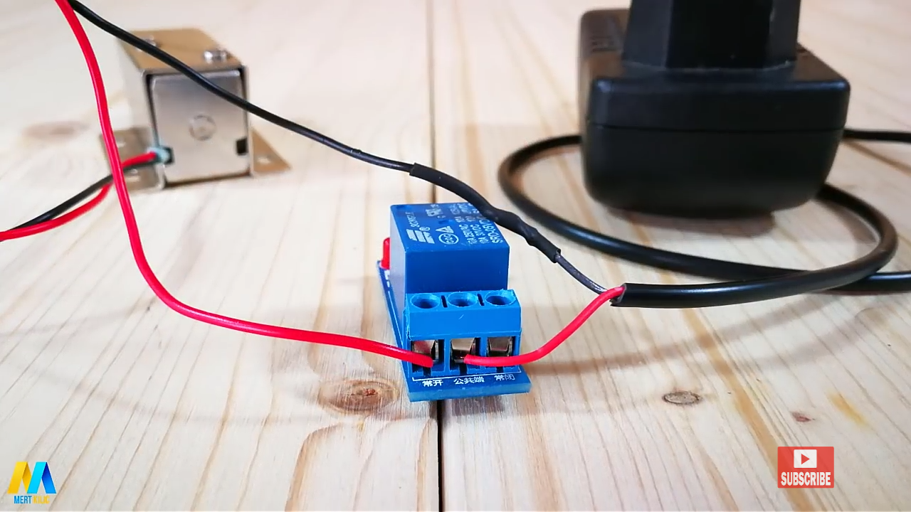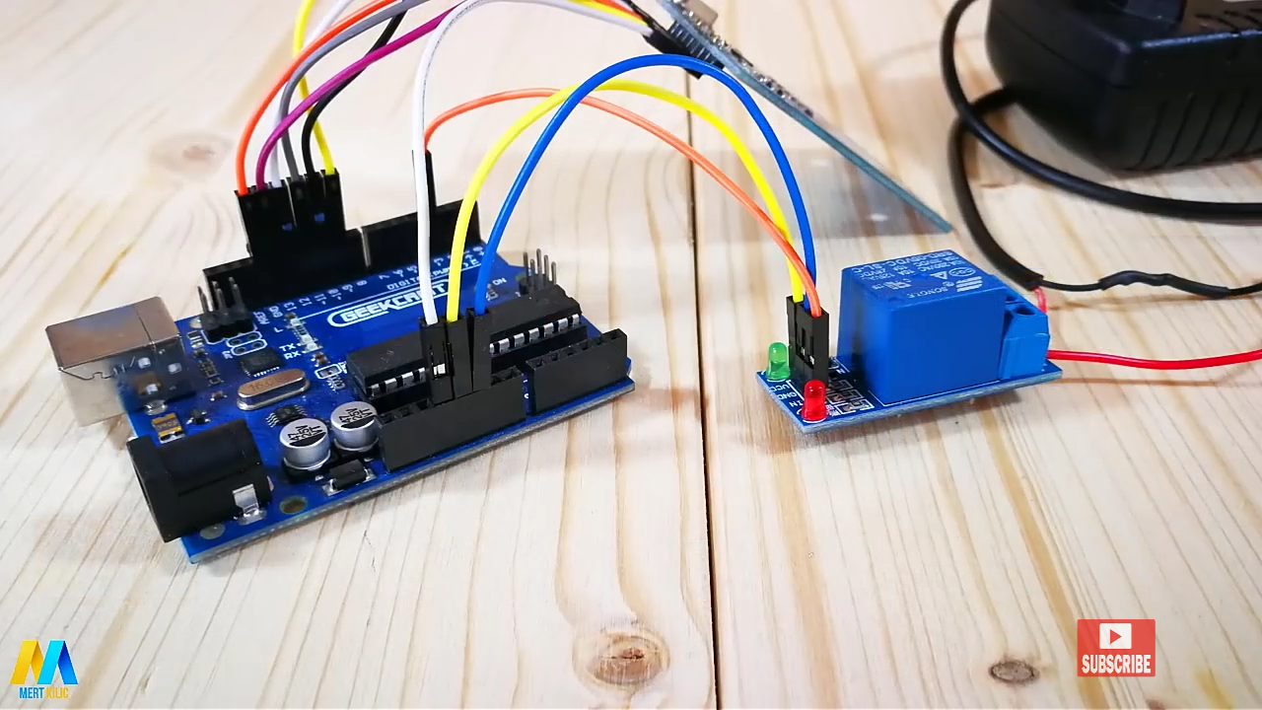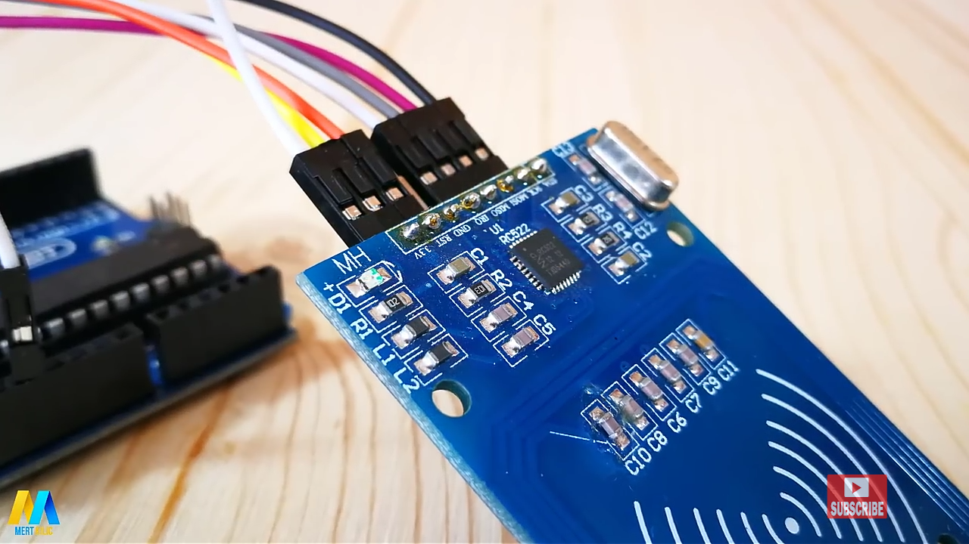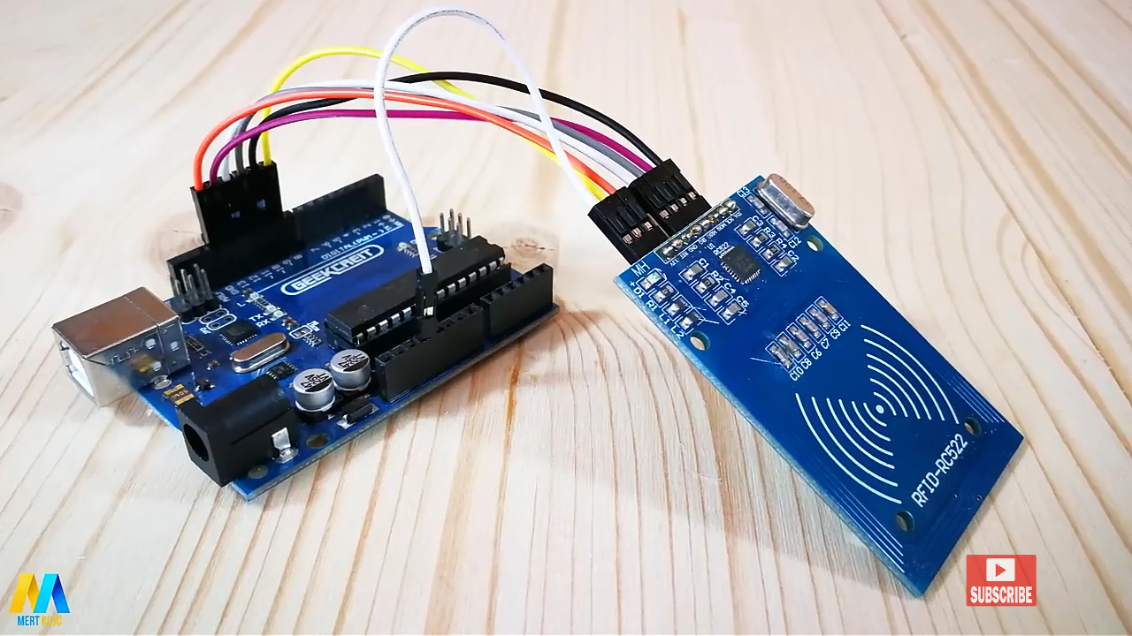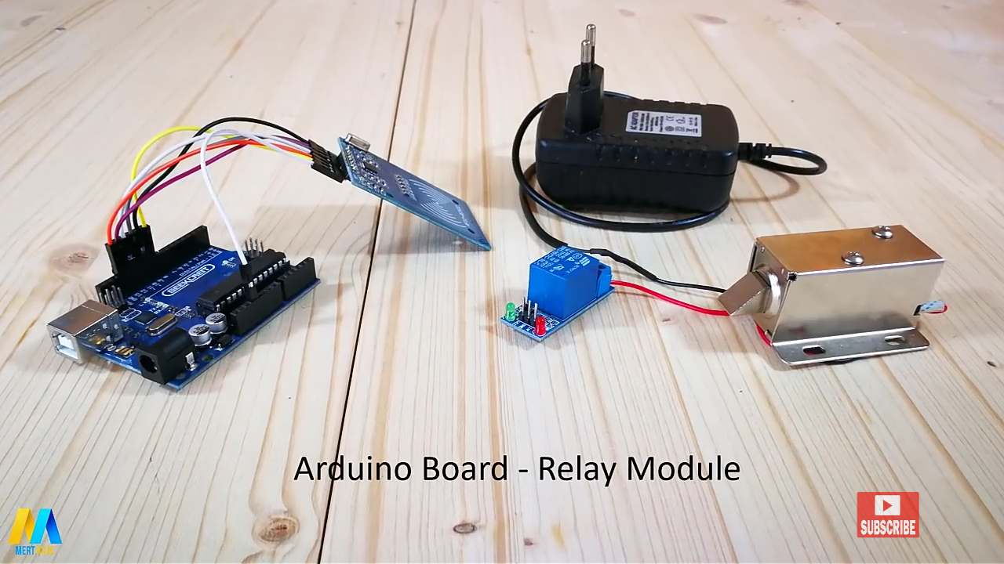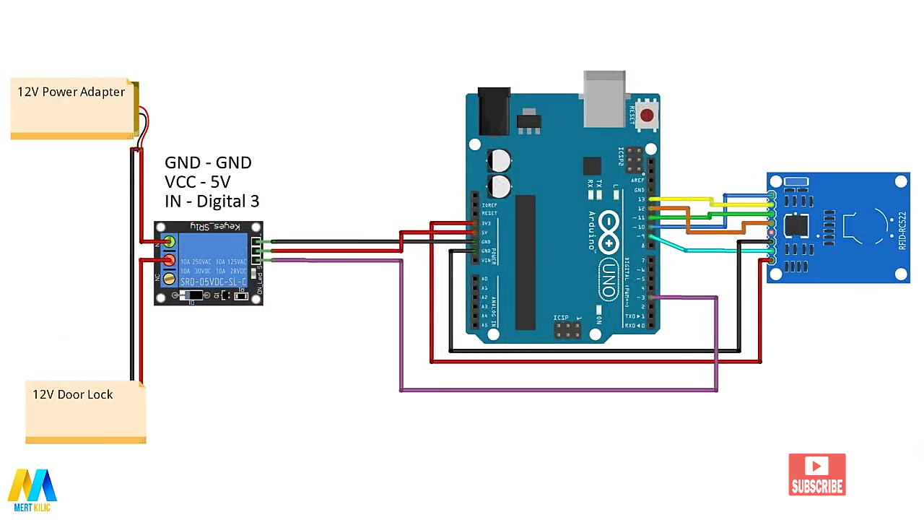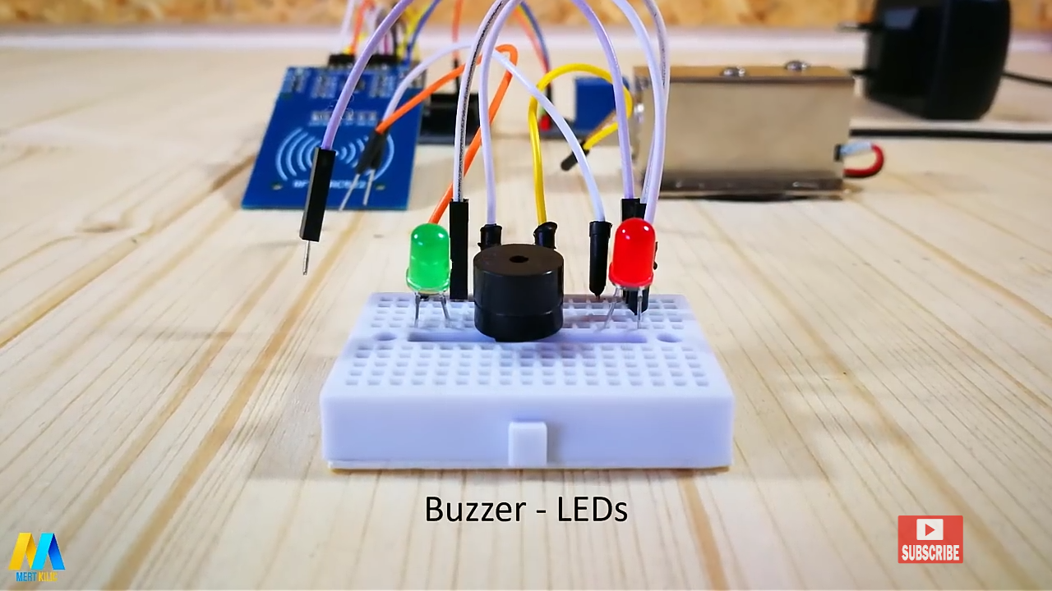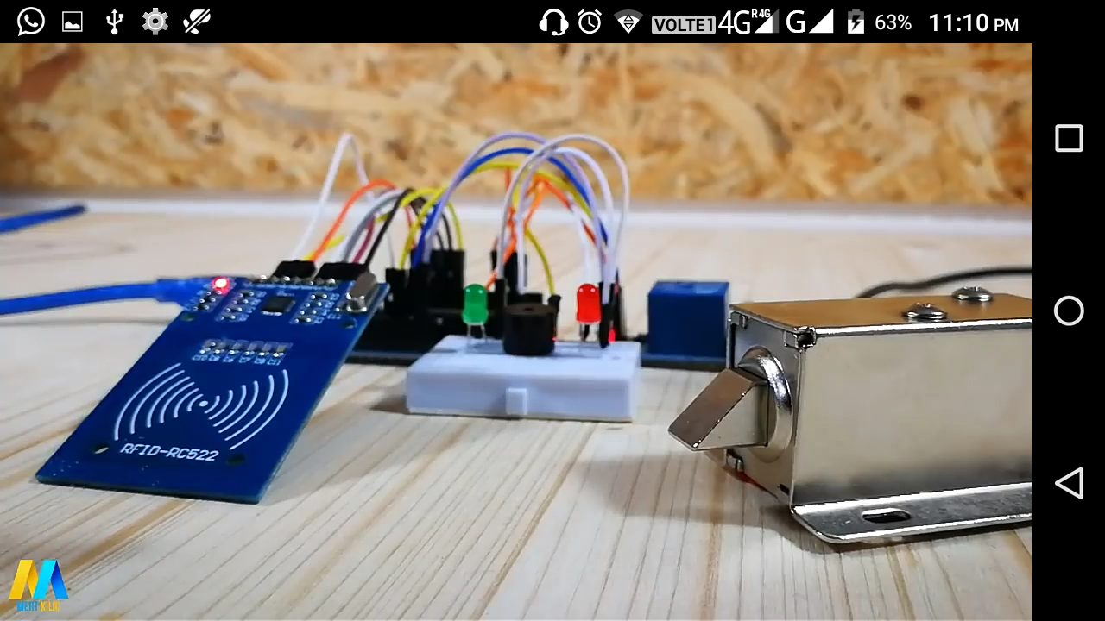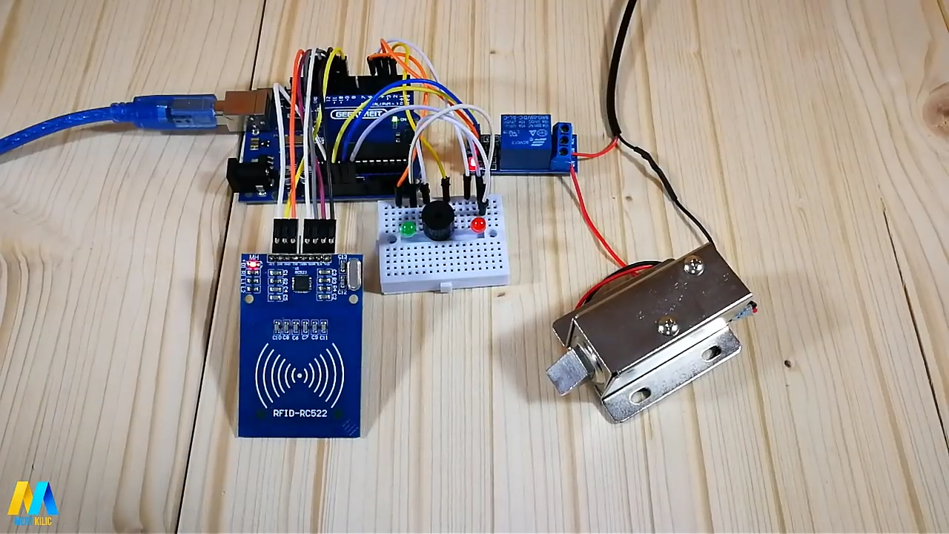

# Program Code

(*Link of your Github project*)

#include <SPI.h>

#include <MFRC522.h>

#define SS_PIN 10

#define RST_PIN 9

#define LED_G 5 //define green LED pin

#define LED_R 4 //define red LED

#define RELAY 3 //relay pin

#define BUZZER 2 //buzzer pin

#define ACCESS_DELAY 2000

#define DENIED_DELAY 1000

MFRC522 mfrc522(SS_PIN, RST_PIN); // Create MFRC522 instance.

void setup()

{

Serial.begin(9600); // Initiate a serial communication

SPI.begin(); // Initiate SPI bus

mfrc522.PCD_Init(); // Initiate MFRC522

pinMode(LED_G, OUTPUT);

pinMode(LED_R, OUTPUT);

pinMode(RELAY, OUTPUT);

pinMode(BUZZER, OUTPUT);

noTone(BUZZER);

digitalWrite(RELAY, HIGH);

Serial.println("Put your card to the reader...");

Serial.println();}

void loop()

{// Look for new cards

if ( ! mfrc522.PICC_IsNewCardPresent())

{

return; }

// Select one of the cards

if ( ! mfrc522.PICC_ReadCardSerial())

{return;

}

//Show UID on serial monitor

Serial.print("UID tag :");

String content= "";

byte letter;

for (byte i = 0; i < mfrc522.uid.size; i++)

{ Serial.print(mfrc522.uid.uidByte[i] < 0x10 ? " 0" : " ");

Serial.print(mfrc522.uid.uidByte[i], HEX);

content.concat(String(mfrc522.uid.uidByte[i] < 0x10 ? " 0" : " "));

content.concat(String(mfrc522.uid.uidByte[i], HEX));}

Serial.println();

Serial.print("Message : ");

content.toUpperCase();

if (content.substring(1) == "E2 F6 73 2E") //change here the UID of the card/cards that you want to give access

{ Serial.println("Authorized access");

Serial.println();

delay(500);

digitalWrite(RELAY, LOW);

digitalWrite(LED_G, HIGH);

delay(ACCESS_DELAY);

digitalWrite(RELAY, HIGH);

digitalWrite(LED_G, LOW);}

else {Serial.println(" Access denied");

digitalWrite(LED_R, HIGH);

tone(BUZZER, 300);

delay(DENIED_DELAY);

digitalWrite(LED_R, LOW);

noTone(BUZZER);}}